Rubén Comerón Galán

Sesión 2
Modelo de puerta NAND:

ENTITY op_nand_n IS
GENERIC (n: INTEGER:=8);
PORT (x, y: IN BIT_VECTOR(n-1 DOWNTO 0); r:OUT BIT_VECTOR(n-1 DOWNTO 0));
END op_nand_n;

ARCHITECTURE estructural OF op_nand_n IS
COMPONENT nand2
PORT (e1, e2: IN BIT; sal: OUT BIT);
END COMPONENT;
BEGIN
bateria: FOR i IN 0 TO n-1 GENERATE
puertas: nand2 PORT MAP (x(i), y(i), r(i));
END GENERATE;
END estructural;

Modelo del test-bench de la puerta NAND:

ENTITY tb_op_nand_n IS
END tb_op_nand_n;

ARCHITECTURE estructural OF tb_op_nand_n IS
COMPONENT op_nand_n
GENERIC (n: INTEGER:=8);
PORT (x, y: IN BIT_VECTOR(n-1 DOWNTO 0); r: OUT BIT_VECTOR(n-1 DOWNTO 0));
END COMPONENT;

FOR operador: op_nand_n USE ENTITY WORK.op_nand_n(estructural);

CONSTANT TAMANO_PALABRA: integer := 2;

SIGNAL A, B, C: BIT_VECTOR(TAMANO_PALABRA-1 DOWNTO 0);

BEGIN
operador: op_nand_n GENERIC MAP (TAMANO_PALABRA) PORT MAP(A, B, C);

PROCESS
VARIABLE valor, limite: INTEGER;
BEGIN
limite:= 2**TAMANO_PALABRA-1;

FOR i IN 0 TO limite LOOP
valor:=i;

FOR k IN A'REVERSE_RANGE LOOP
A(k)<=BIT'VAL(valor REM 2);
valor:=valor/2;
END LOOP;

FOR j IN 0 TO limite LOOP
valor:=j;

FOR k IN B'REVERSE_RANGE LOOP
B(k)<=BIT'VAL(valor REM 2);
valor:=valor/2;
END LOOP;
WAIT FOR 2 ns;

END LOOP;
END LOOP;

WAIT FOR 2 ns;
WAIT;
END PROCESS;
END estructural;

Resultado de la prueba del test-bench de la puerta NAND:

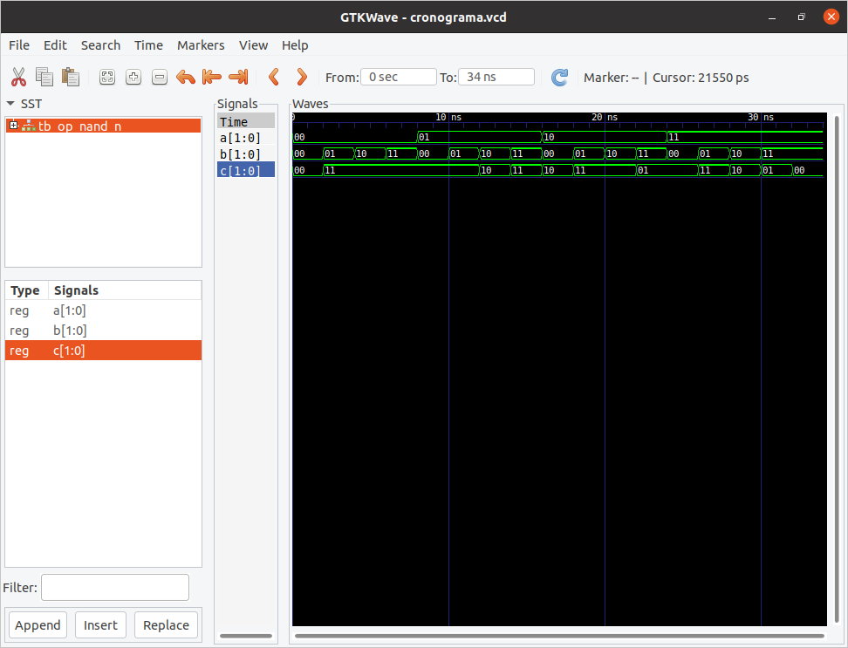

Modelo de puerta NOR:

ENTITY op_nor_n IS
GENERIC (n: INTEGER:=8);
PORT (x, y: IN BIT_VECTOR(n-1 DOWNTO 0); r:OUT BIT_VECTOR(n-1 DOWNTO 0));
END op_nor_n;

ARCHITECTURE estructural OF op_nor_n IS
COMPONENT nor2
PORT (e1, e2: IN BIT; sal: OUT BIT);
END COMPONENT;
BEGIN
bateria: FOR i IN 0 TO n-1 GENERATE
puertas: nor2 PORT MAP (x(i), y(i), r(i));
END GENERATE;
END estructural;

Modelo del test-bench de la puerta NOR:

ENTITY tb_op_nor_n IS
END tb_op_nor_n;

ARCHITECTURE estructural OF tb_op_nor_n IS
COMPONENT op_nor_n
GENERIC (n: INTEGER:=8);
PORT (x, y: IN BIT_VECTOR(n-1 DOWNTO 0); r: OUT BIT_VECTOR(n-1 DOWNTO 0));
END COMPONENT;

FOR operador: op_nor_n USE ENTITY WORK.op_nor_n(estructural);

CONSTANT TAMANO_PALABRA: integer := 2;

SIGNAL A, B, C: BIT_VECTOR(TAMANO_PALABRA-1 DOWNTO 0);

BEGIN
operador: op_nor_n GENERIC MAP (TAMANO_PALABRA) PORT MAP(A, B, C);

PROCESS
VARIABLE valor, limite: INTEGER;
BEGIN
limite:= 2**TAMANO_PALABRA-1;

FOR i IN 0 TO limite LOOP
valor:=i;

FOR k IN A'REVERSE_RANGE LOOP
A(k)<=BIT'VAL(valor REM 2);
valor:=valor/2;
END LOOP;

FOR j IN 0 TO limite LOOP
valor:=j;

FOR k IN B'REVERSE_RANGE LOOP
B(k)<=BIT'VAL(valor REM 2);
valor:=valor/2;
END LOOP;
WAIT FOR 2 ns;

END LOOP;
END LOOP;

WAIT FOR 2 ns;
WAIT;
END PROCESS;
END estructural;

Resultado de la prueba del test-bench de la puerta NOR:

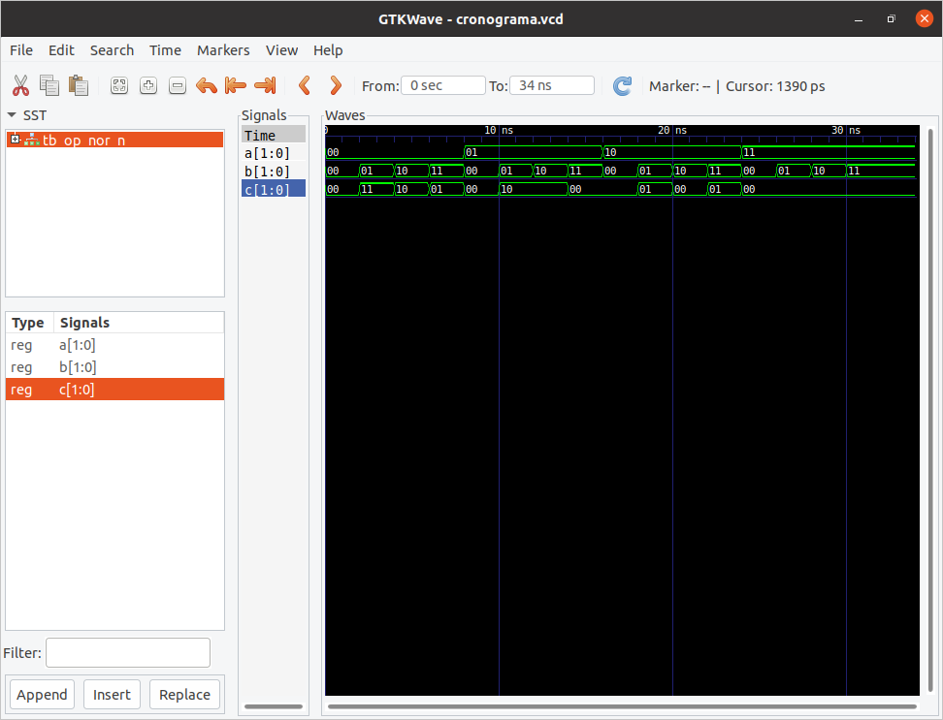

Modelo de puerta NOT:

ENTITY op_not_n IS
GENERIC (n: INTEGER:=8);
PORT (x, y: IN BIT_VECTOR(n-1 DOWNTO 0); r, s:OUT BIT_VECTOR(n-1 DOWNTO 0));
END op_not_n;

ARCHITECTURE estructural OF op_not_n IS
COMPONENT not2
PORT (e1, e2: IN BIT; sal1, sal2: OUT BIT);
END COMPONENT;
BEGIN
bateria: FOR i IN 0 TO n-1 GENERATE
puertas: not2 PORT MAP (x(i), y(i), r(i), s(i));
END GENERATE;
END estructural;

Modelo del test-bench de la puerta NOT:

ENTITY tb_op_not_n IS
END tb_op_not_n;

ARCHITECTURE estructural OF tb_op_not_n IS
COMPONENT op_not_n
GENERIC (n: INTEGER:=8);
PORT (x: IN BIT_VECTOR(n-1 DOWNTO 0); s: OUT BIT_VECTOR(n-1 DOWNTO 0));
END COMPONENT;

FOR operador: op_not_n USE ENTITY WORK.op_not_n(estructural);

CONSTANT TAMANO_PALABRA: integer := 2;

SIGNAL A, B: BIT_VECTOR(TAMANO_PALABRA-1 DOWNTO 0);

BEGIN
operador: op_not_n GENERIC MAP (TAMANO_PALABRA) PORT MAP(A, B);

PROCESS
VARIABLE valor, limite: INTEGER;
BEGIN
limite:= 2**TAMANO_PALABRA-1;

FOR i IN 0 TO limite LOOP
valor:=i;

FOR k IN A'REVERSE_RANGE LOOP
A(k)<=BIT'VAL(valor REM 2);
valor:=valor/2;
END LOOP;
WAIT FOR 2 ns;

END LOOP;

WAIT FOR 2 ns;
WAIT;
END PROCESS;
END estructural;

Resultado de la prueba del test-bench de la puerta NOT:
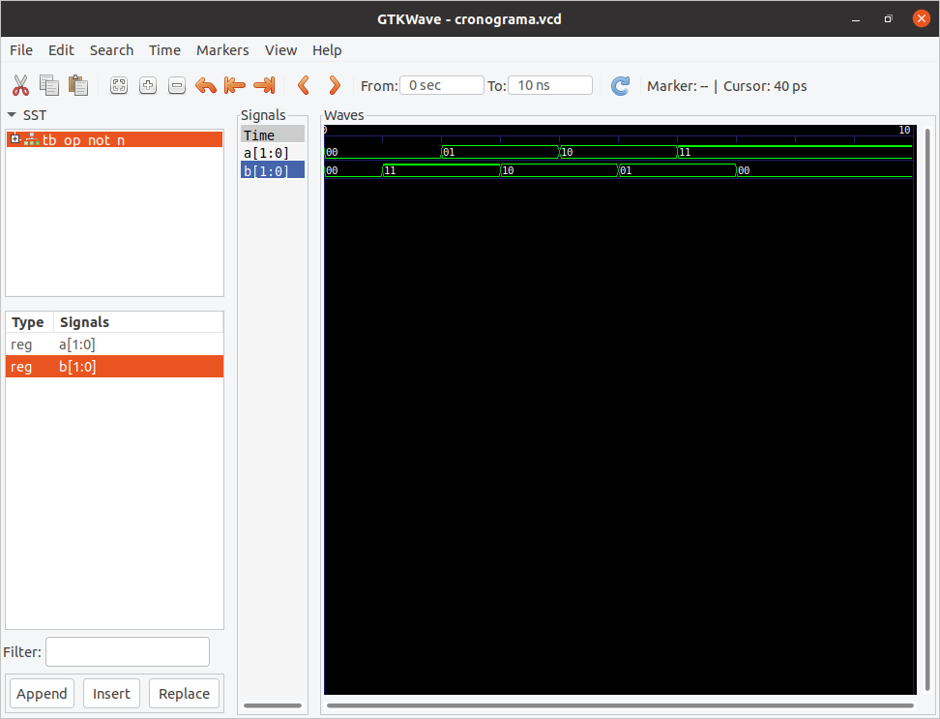

Modelo de puerta XOR:

ENTITY op_xor_n IS
GENERIC (n: INTEGER:=8);
PORT (x, y: IN BIT_VECTOR(n-1 DOWNTO 0); r:OUT BIT_VECTOR(n-1 DOWNTO 0));
END op_xor_n;

ARCHITECTURE estructural OF op_xor_n IS
COMPONENT xor2
PORT (e1, e2: IN BIT; sal: OUT BIT);
END COMPONENT;
BEGIN
bateria: FOR i IN 0 TO n-1 GENERATE
puertas: xor2 PORT MAP (x(i), y(i), r(i));
END GENERATE;
END estructural;

Modelo del test-bench de la puerta XOR:

ENTITY tb_op_xor_n IS
END tb_op_xor_n;

ARCHITECTURE estructural OF tb_op_xor_n IS
COMPONENT op_xor_n
GENERIC (n: INTEGER:=8);
PORT (x, y: IN BIT_VECTOR(n-1 DOWNTO 0); r: OUT BIT_VECTOR(n-1 DOWNTO 0));
END COMPONENT;

FOR operador: op_xor_n USE ENTITY WORK.op_xor_n(estructural);

CONSTANT TAMANO_PALABRA: integer := 2;

SIGNAL A, B, C: BIT_VECTOR(TAMANO_PALABRA-1 DOWNTO 0);

BEGIN
operador: op_xor_n GENERIC MAP (TAMANO_PALABRA) PORT MAP(A, B, C);

PROCESS
VARIABLE valor, limite: INTEGER;
BEGIN
limite:= 2**TAMANO_PALABRA-1;

FOR i IN 0 TO limite LOOP
valor:=i;

FOR k IN A'REVERSE_RANGE LOOP
A(k)<=BIT'VAL(valor REM 2);
valor:=valor/2;
END LOOP;

FOR j IN 0 TO limite LOOP
valor:=j;

FOR k IN B'REVERSE_RANGE LOOP
B(k)<=BIT'VAL(valor REM 2);
valor:=valor/2;
END LOOP;
WAIT FOR 2 ns;

END LOOP;
END LOOP;

WAIT FOR 2 ns;
WAIT;
END PROCESS;
END estructural;

Resultado del test-bench de la puerta XOR:

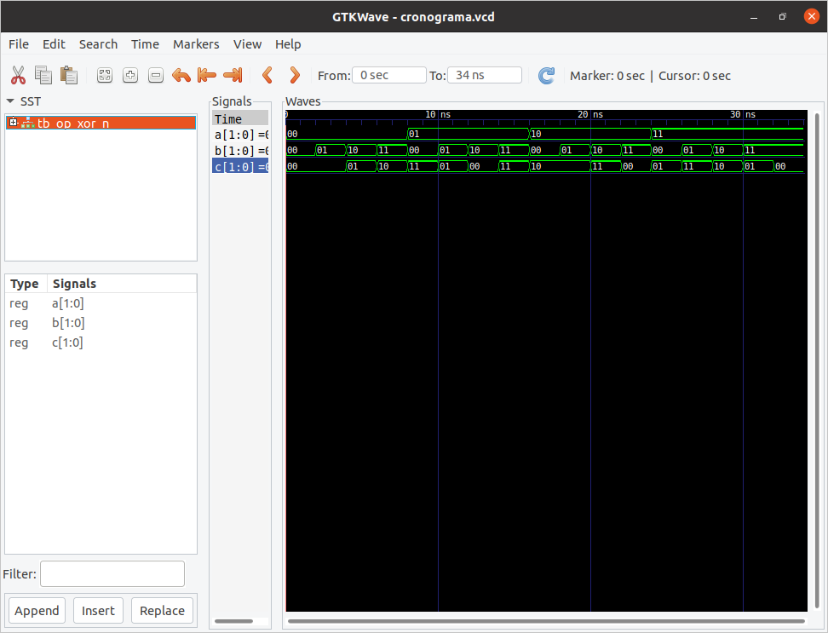

Modelo de puerta OR:

ENTITY op_or_n IS
GENERIC (n: INTEGER:=8);
PORT (x, y: IN BIT_VECTOR(n-1 DOWNTO 0); r:OUT BIT_VECTOR(n-1 DOWNTO 0));
END op_or_n;

ARCHITECTURE estructural OF op_or_n IS
COMPONENT or2
PORT (e1, e2: IN BIT; sal: OUT BIT);
END COMPONENT;
BEGIN
bateria: FOR i IN 0 TO n-1 GENERATE
puertas: or2 PORT MAP (x(i), y(i), r(i));
END GENERATE;
END estructural;

Modelo del test-bench de la puerta OR:

ENTITY tb_op_or_n IS
END tb_op_or_n;

ARCHITECTURE estructural OF tb_op_or_n IS
COMPONENT op_or_n
GENERIC (n: INTEGER:=8);
PORT (x, y: IN BIT_VECTOR(n-1 DOWNTO 0); r: OUT BIT_VECTOR(n-1 DOWNTO 0));
END COMPONENT;

FOR operador: op_or_n USE ENTITY WORK.op_or_n(estructural);

CONSTANT TAMANO_PALABRA: integer := 2;

SIGNAL A, B, C: BIT_VECTOR(TAMANO_PALABRA-1 DOWNTO 0);

BEGIN
operador: op_or_n GENERIC MAP (TAMANO_PALABRA) PORT MAP(A, B, C);

PROCESS
VARIABLE valor, limite: INTEGER;
BEGIN
limite:= 2**TAMANO_PALABRA-1;

FOR i IN 0 TO limite LOOP
valor:=i;

FOR k IN A'REVERSE_RANGE LOOP
A(k)<=BIT'VAL(valor REM 2);
valor:=valor/2;
END LOOP;

FOR j IN 0 TO limite LOOP
valor:=j;

FOR k IN B'REVERSE_RANGE LOOP
B(k)<=BIT'VAL(valor REM 2);
valor:=valor/2;
END LOOP;
WAIT FOR 2 ns;

END LOOP;
END LOOP;

WAIT FOR 2 ns;
WAIT;
END PROCESS;
END estructural;

Resultado del test-bench de la puerta OR:

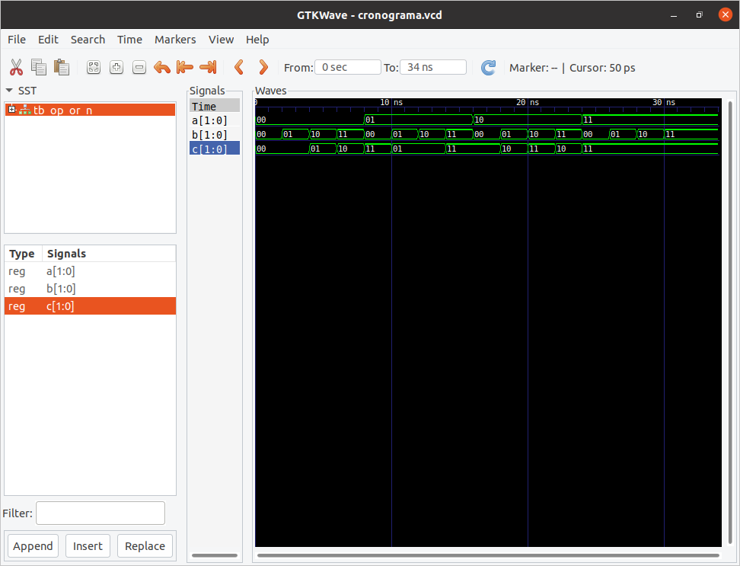

Modelo de inversor condicional:

ENTITY inversor_condicional IS
GENERIC (n: INTEGER:=8);
PORT (x, y: IN BIT_VECTOR(n-1 DOWNTO 0); r:OUT BIT_VECTOR(n-1 DOWNTO 0));
END inversor_condicional;

ARCHITECTURE estructural OF inversor_condicional IS
COMPONENT xor2
PORT (e1, e2: IN BIT; sal: OUT BIT);
END COMPONENT;
BEGIN
bateria: FOR i IN 0 TO n-1 GENERATE
puertas: xor2 PORT MAP (x(i), y(i), r(i));
END GENERATE;
END estructural;

Modelo del test-bench del inversor condicional:

ENTITY tb_inversor_condicional IS
END tb_inversor_condicional;

ARCHITECTURE estructural OF tb_inversor_condicional IS
COMPONENT inversor_condicional
GENERIC (n: INTEGER:=8);
PORT (x, y: IN BIT_VECTOR(n-1 DOWNTO 0); r: OUT BIT_VECTOR(n-1 DOWNTO 0));
END COMPONENT;

FOR operador: inversor_condicional USE ENTITY WORK.inversor_condicional(estructural);

CONSTANT TAMANO_PALABRA: integer := 2;

SIGNAL A, B, C: BIT_VECTOR(TAMANO_PALABRA-1 DOWNTO 0);

BEGIN
operador: inversor_condicional GENERIC MAP (TAMANO_PALABRA) PORT MAP(A, B, C); --B es la señal ENABLE

PROCESS
VARIABLE valor, limite, ENABLE: INTEGER;
BEGIN
limite:= 2**TAMANO_PALABRA-1;
ENABLE:=1;

FOR i IN 0 TO limite LOOP
valor:=i;

FOR k IN A'REVERSE_RANGE LOOP
A(k)<=BIT'VAL(valor REM 2);
valor:=valor/2;
END LOOP;

FOR j IN 0 TO limite LOOP
valor:=j;

FOR k IN B'REVERSE_RANGE LOOP
B(k)<=BIT'VAL(ENABLE);
valor:=valor/2;
END LOOP;
WAIT FOR 2 ns;

END LOOP;
END LOOP;

WAIT FOR 2 ns;

ENABLE:=0;

FOR i IN 0 TO limite LOOP
valor:=i;

FOR k IN A'REVERSE_RANGE LOOP
A(k)<=BIT'VAL(valor REM 2);
valor:=valor/2;
END LOOP;

FOR j IN 0 TO limite LOOP
valor:=j;

FOR k IN B'REVERSE_RANGE LOOP
B(k)<=BIT'VAL(ENABLE);
valor:=valor/2;
END LOOP;
WAIT FOR 2 ns;

END LOOP;
END LOOP;

WAIT FOR 2 ns;
WAIT;

END PROCESS;
END estructural;

Resultado del test-bench del inversor condicional:

